Ceredigion:

1. Bot has clicked the “**Launch the Search Facility”** Link

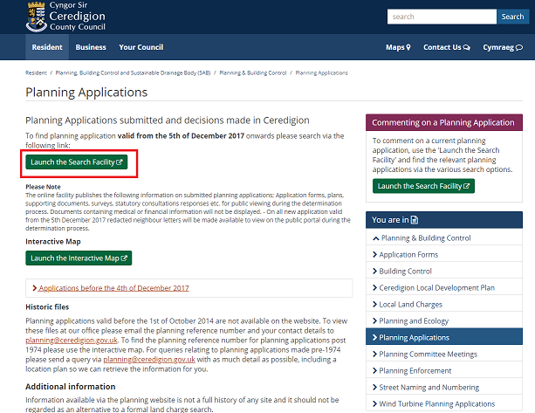

1. Clicked on “**Search Planning Applications”**

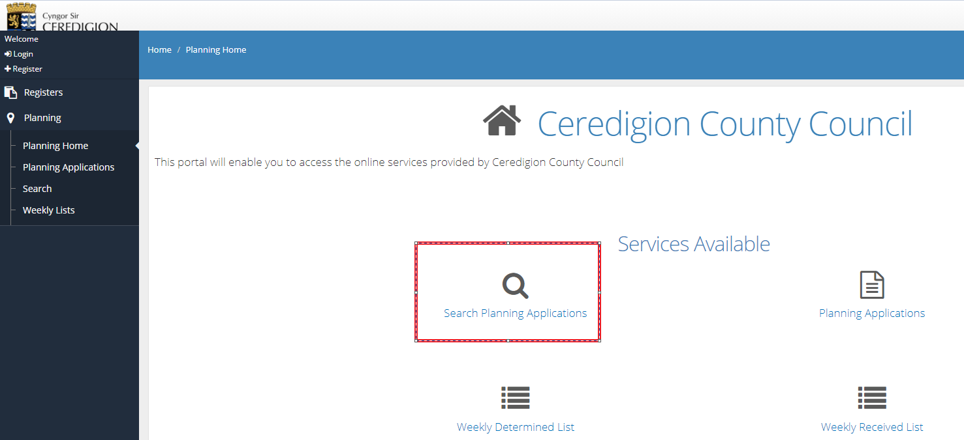

1. In **“Site Address Description”** bot has entered first line of address (house number/name and street)

Note: We didn’t get an site address to search, so we given bot an keyword “Ceredigion” to enter in site address description

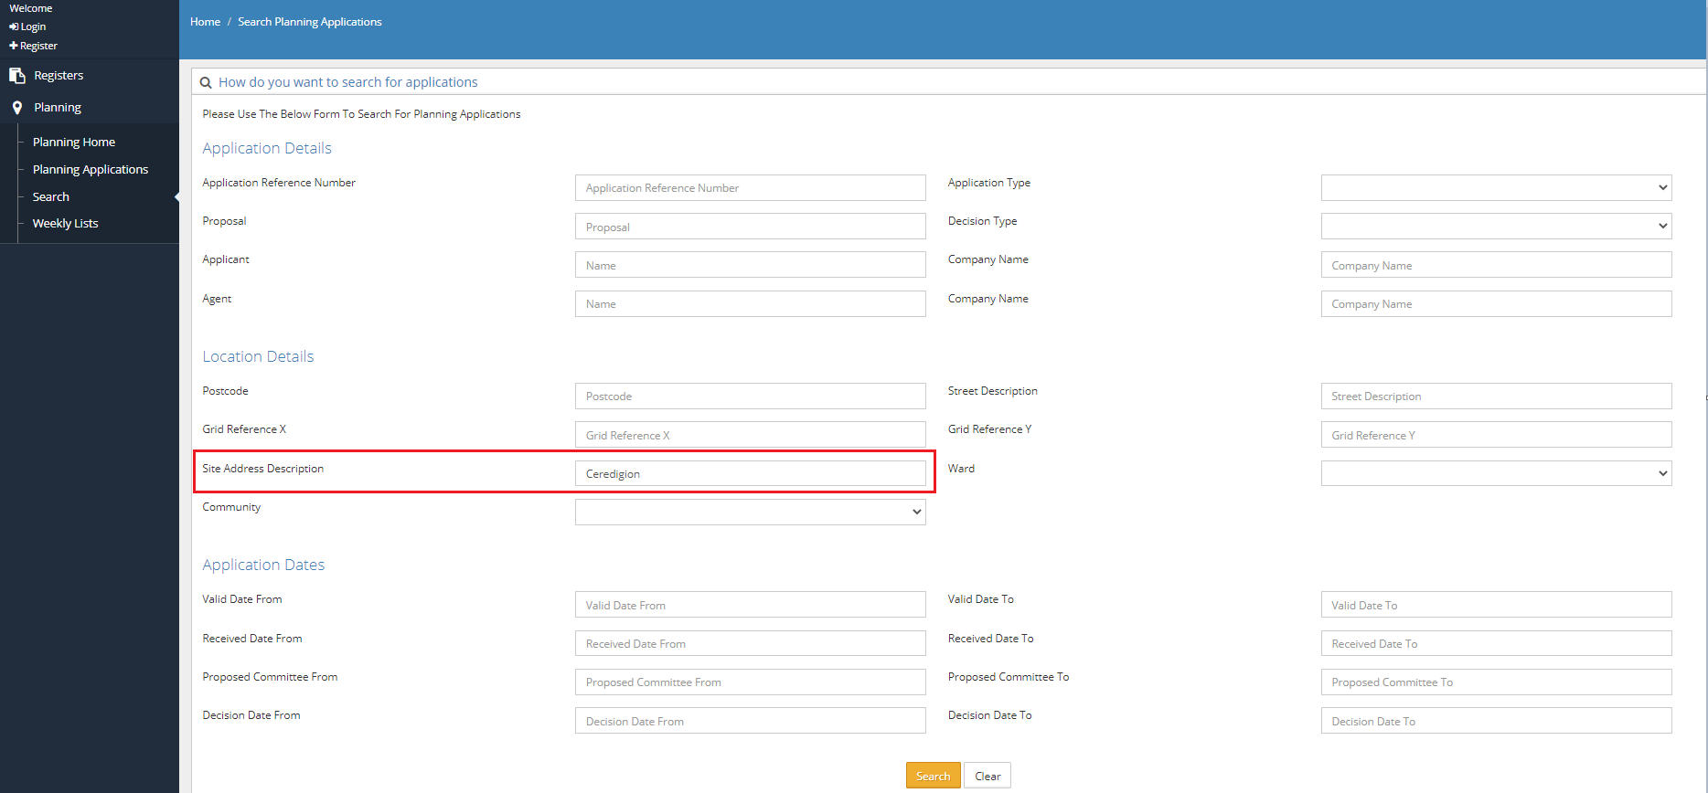

1. Multiple Results has shown for the keyword we searched , Now Bot will click **“view”** to reveal full details.

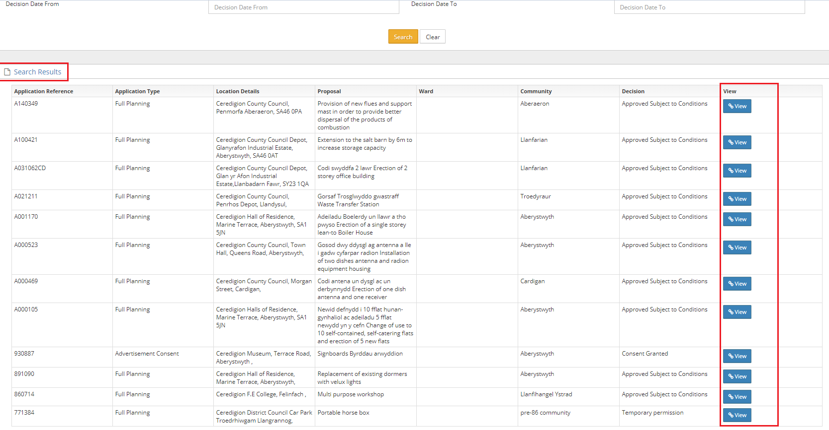

1. The application details are shown which are slightly differ compare to other websites

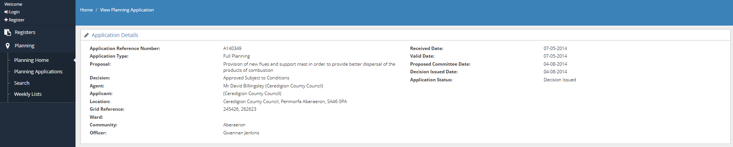

1. So the bot has extracted every fields in that planning applications

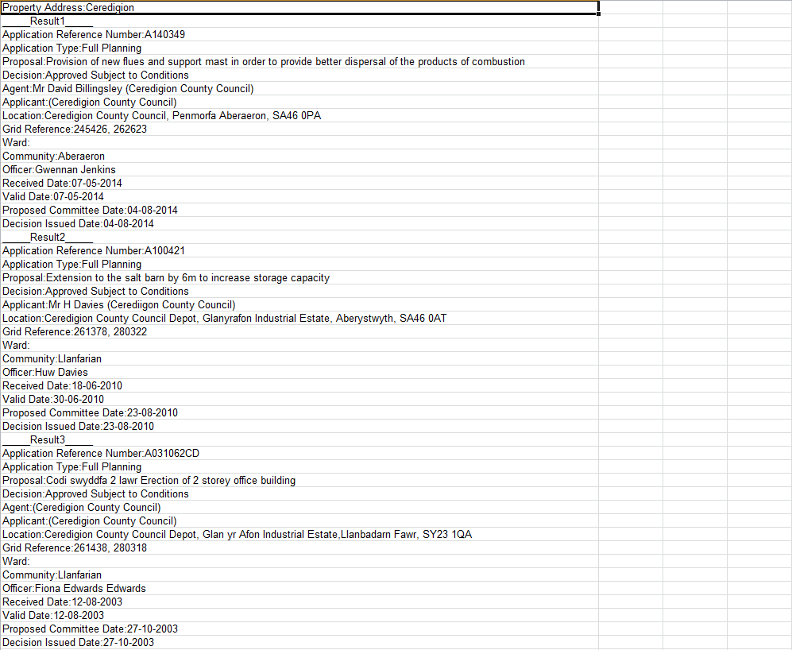

## Questions:

1. What are the fields that the bot need to extract from the planning application or is it good to extract all fields?

Responses:

1. Essential fields to be extracted as follows:

Application Reference Number

Application Type

Proposal

Decision

Location

Decision Issued Date

Spacing is again an issue on excel response.